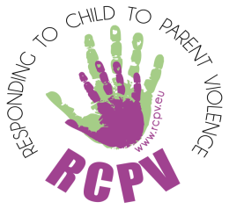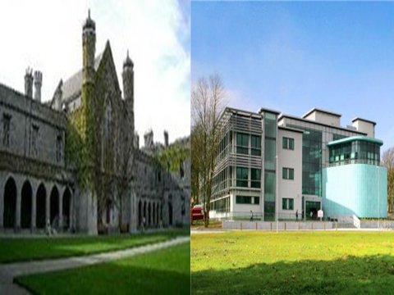
DAPHNE CONFERENCE ON CHILD TO PARENT VIOLENCE IN GALWAY: Innovations in Practice, Policy and Research, NUIG, 12 & 13 June 2014
Big thanks for organising a very successful Daphne Responding to Child to Parent Violence (RCPV) Conference on 12 and 13 June go to the NUI Galway team of Declan Coogan and Eileen Lauster, to the local partners COPE Galway (Waterside House) Domestic Violence Services and the graduate student volunteers in the School of Political Science & Sociology. The conference was attended by nearly 200 practitioners and academics from the Republic of Ireland, Bulgaria, Spain, Sweden and England.

RCPV Partnership The team that went from UoB was Dr Paula Wilcox, P.I., Claire Thompson, PM and Alexia Papamichail, research assistant. Accompanying us from BHCC was joint lead of the project Michelle Pooley, from Rise/Break4Change Pam Nicholls, Martyn Stoner BHCC YOS/ B4C and Alice Ross, AudioActive.

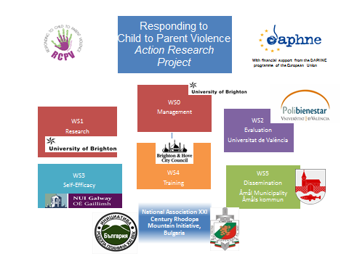

RCPV Goals
- Raise awareness of CPV
- Research understanding and capture good practice
- Develop evaluation framework-pilot with 2 models: Break4Change & Non Violent Resistance
- Build capacity by implementing intervention programmes
- Develop tools for practitioners and families

With an underpinning focus on gender and VAW.

News from the Conference

A warm welcome

The delegates were warmly welcomed by Caroline McGregor, Professor of Social Work, School of Political Science and Sociology at NUI Galway.

The Conference was officially opened by Norah Gibbons, Chairperson of Tusla, the Child and Family Agency in Ireland. The Child and Family Agency was established on the 1st January 2014 and is now the dedicated State agency responsible for improving wellbeing and outcomes for children. Norah commended Paula Wilcox and the RCPV Project partners for opening this topic up for debate saying that when we look at where we have come from in relation to children and young people, where ‘seen and not heard’ was the norm, it is not hard to understand how difficult it can be to move towards seeing and understanding that as well as being victims of domestic abuse within their families children can also be perpetrators of domestic abuse. She stressed the message from the conference is in essence a simple one that there is never any excuse for violence whether that is domestic or sexual violence, child abuse or child to parent violence. We must seek to understand the causes but never seek to justify.

Keynote Speeches

A memorable keynote address was given by Dr Paula Wilcox (University of Brighton) whose key messages were that CPV is an increasingly common form of domestic abuse and that services need to revise the definition of DV to include CPV, to start counting it in our statistics, and to break the silence around it! What brought the RCPV partners together was the belief that violence of any kind, early in life – experienced, observed or used – can have long-lasting and detrimental impacts on the health, life skills, attitudes and beliefs of children and adults alike.

Michelle Pooley, Brighton and Hove City Council, looked at how the Daphne RCPV programme and CPV programmes are transforming lives and helping to develop respectful relationships between children and parents/carers. She explained a theoretical model to capture the dynamics that families are dealing with at an individual, societal, cultural and economic level whilst assessing the risks and safeguarding issues associated with CPV.

Other keynote speakers included:

Peter Jakob, a Consultant Clinical Psychologist who has been working in this field for many years, spoke about Non Violent Resistance (NVR) and a focus on the child and gave a seminar paper on NVR and Serious Trauma: Working with Multi-Stressed Families.

Eddie Gallagher, Psychologist, Social Worker and Family Therapist from Australia, who has also been working on CPV for a considerable time talked movingly about his work with families and in particular flagged up the parent/mother blaming attitudes found in research and practice when research shows that parents’ influence over their children is far less than most people think and we need to research the effects of children on parents.

Rita O’Reilly CEO of Parentline Ireland said that parents’ calls to Parentline provide a barometer of what is going on for parents. She reported that c. 4,000 parents call each year and of these ‘Abuse’ (which can include CPV) makes up 18% and ‘Teenage Issues’ make up 13% of calls – they say that a child abusing a parent makes up 10% of their calls currently.

Last but not least, the Non Violent Resistance Handbook Ireland (Coogan and Lauster 2014) was launched at the end of the conference by Professor Brid Featherstone, Professor in Social Work in the Faculty of Health and Social Care at The Open University.

RCPV Partner Activities

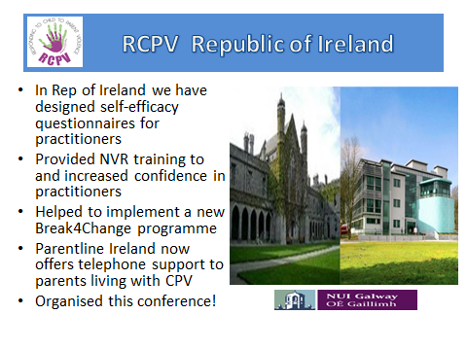
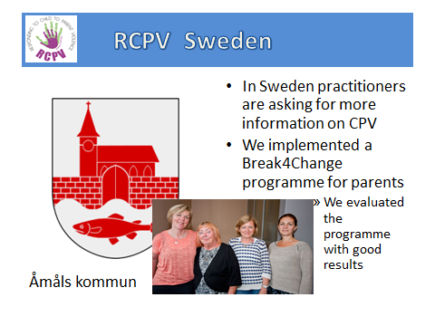

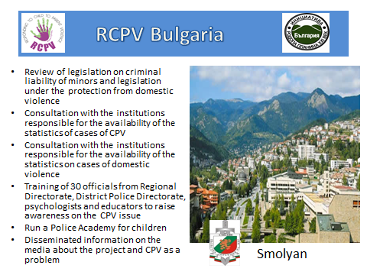

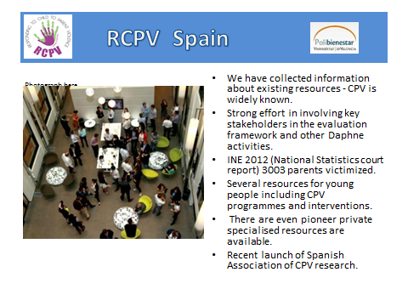

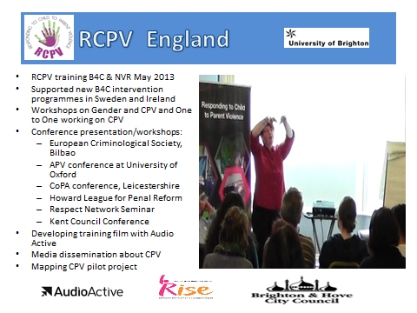

Also at the Conference …..

Through the work of Alice Ross at AudioActive, Michelle Pooley and Paula Wilcox, we have also filmed the majority of the Irish conference and interviewed leading experts in the field of CPV - including Eddie Gallagher, Peter Jakob, Rita O Reilly from Parentline Ireland and all the practitioners who are embedding Break4Change and NVR in their work. This footage will be part of our final end products which will support the reports for the Daphne Programme in Europe. More importantly some of the filming will be used as a resource to help practitioners develop their practice and also provide film for work with parents and young people. We have NUI Galway tech team to thank for their great support in Galway as well as our Irish partners.

All the power point presentations will be available on the Daphne RCPV website www.rcpv.eu.

Next steps

Conference at University of Brighton in Brighton and Hove at the Sallis Benney Hall on the 28th and 29th January 2015.

Paula Wilcox and Claire Thompson
20 June 2014

